1) Create user with name Techie and provide sudo access to user.

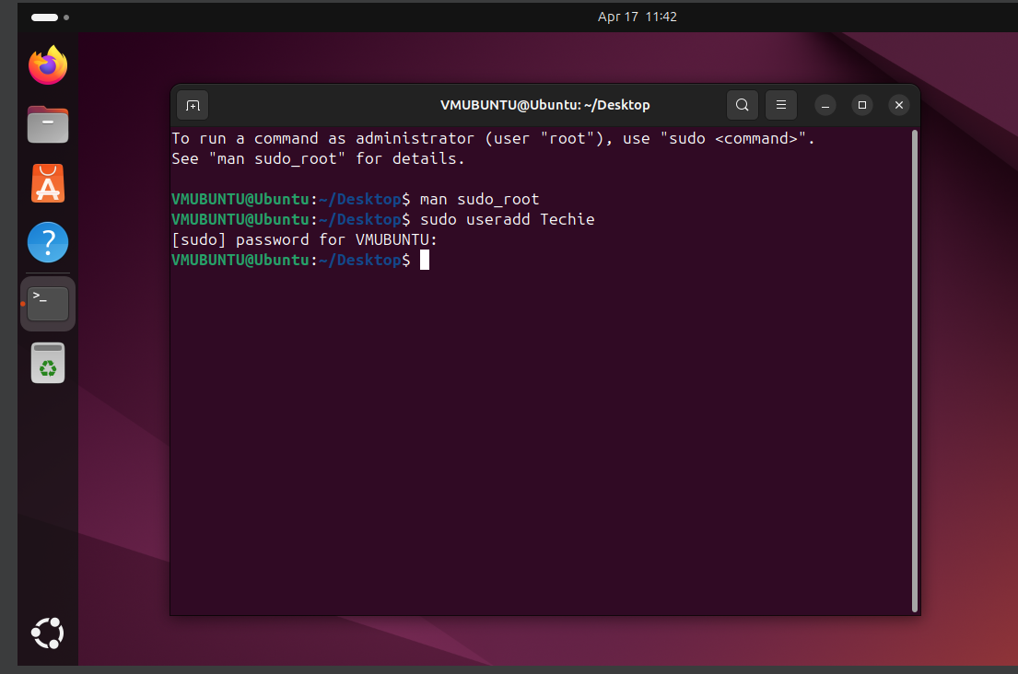

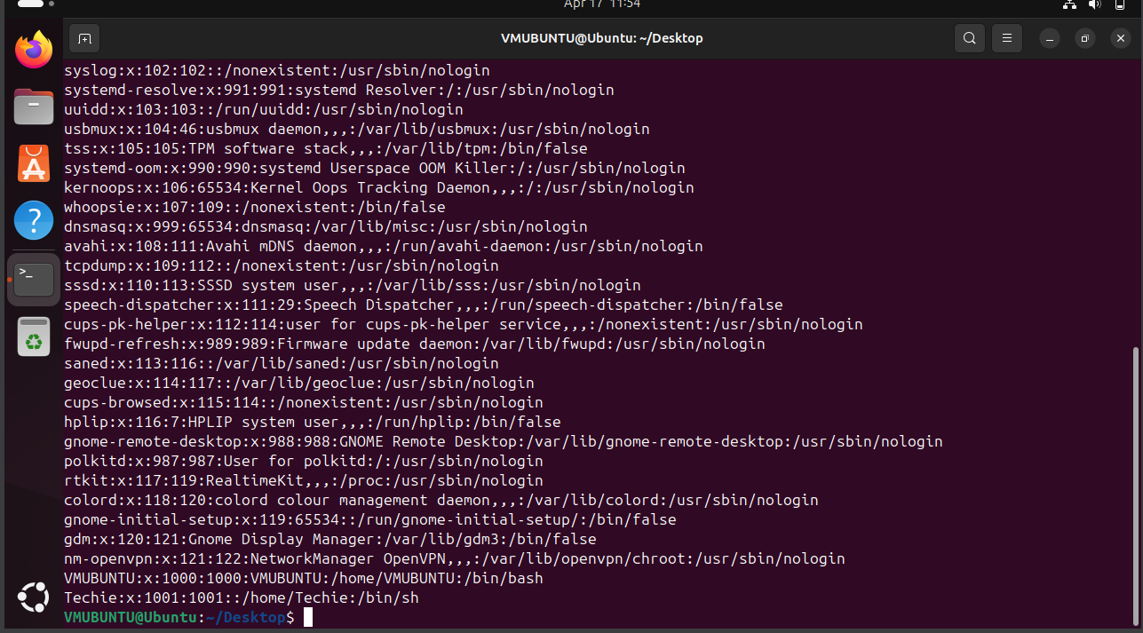

2) Navigate to the home directory.  


3) Create a new directory.



4) List the contents of a directory.

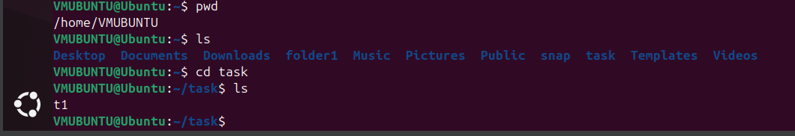

5) Change the current directory.

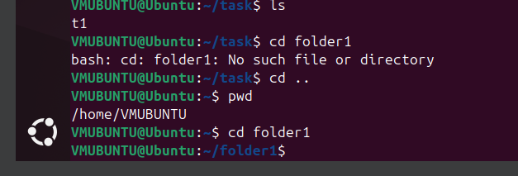

6) Create a new empty file.

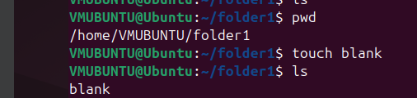

7) View the contents of a file.



8) Copy a file to another location.

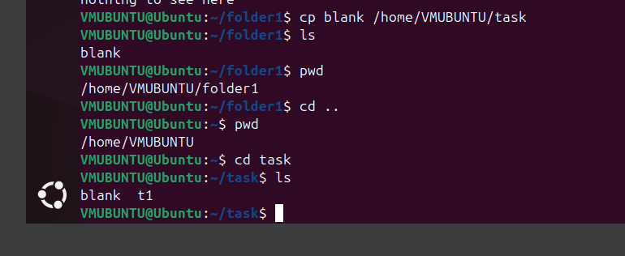

9) Move a file to another location.

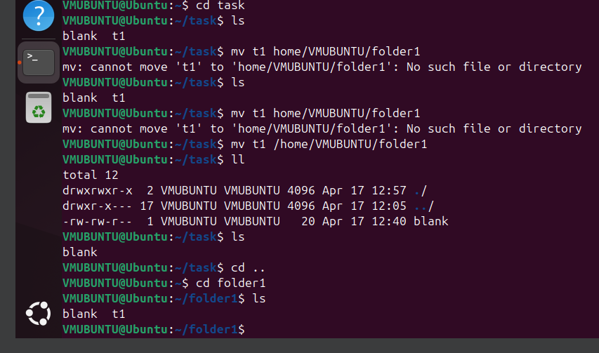

10) Rename a file.

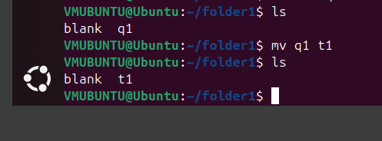

11) Delete a file.

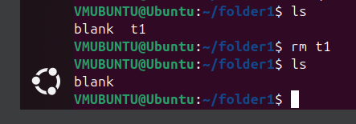

12) Grant or revoke permissions on a file or directory.

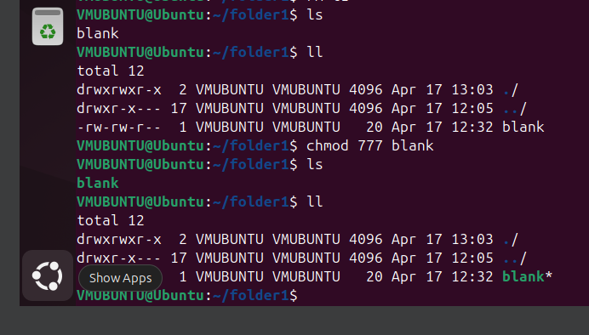

13) View the current date and time.

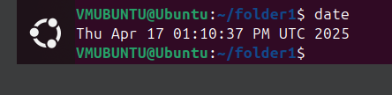

14) Check the system uptime.

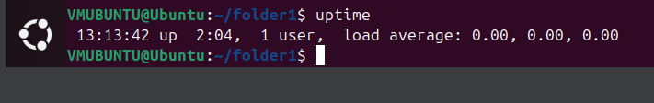

15) View the running processes.

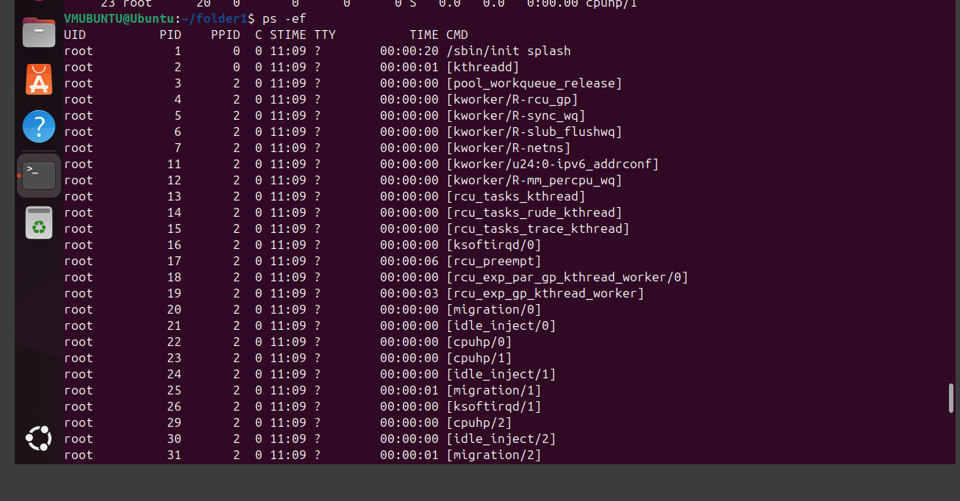

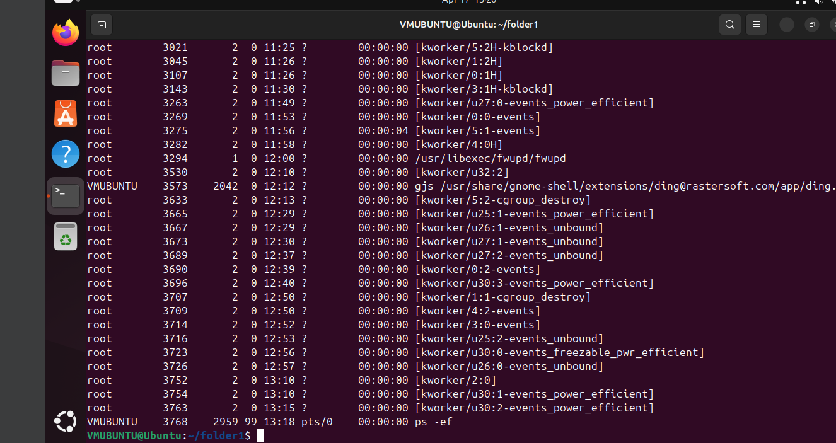

16) Kill a running process.

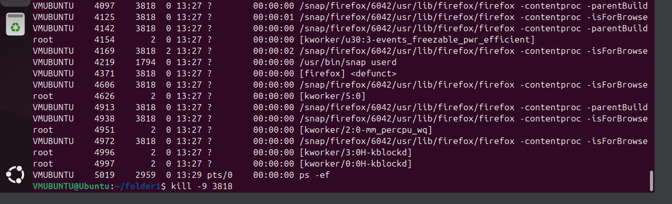

17) Install a package using the package manager (e.g., apt or yum).

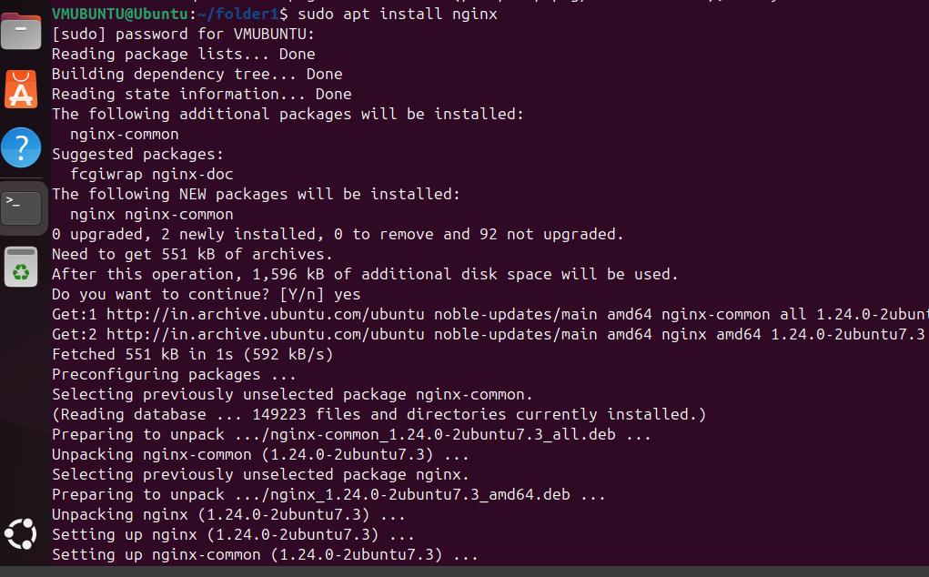

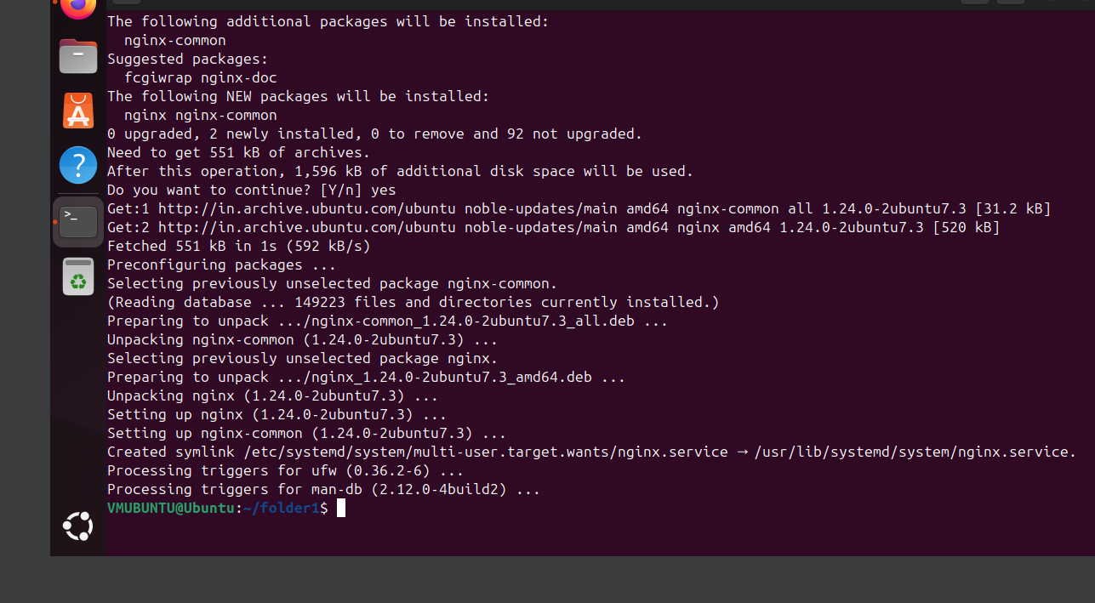

18) Update the system packages.

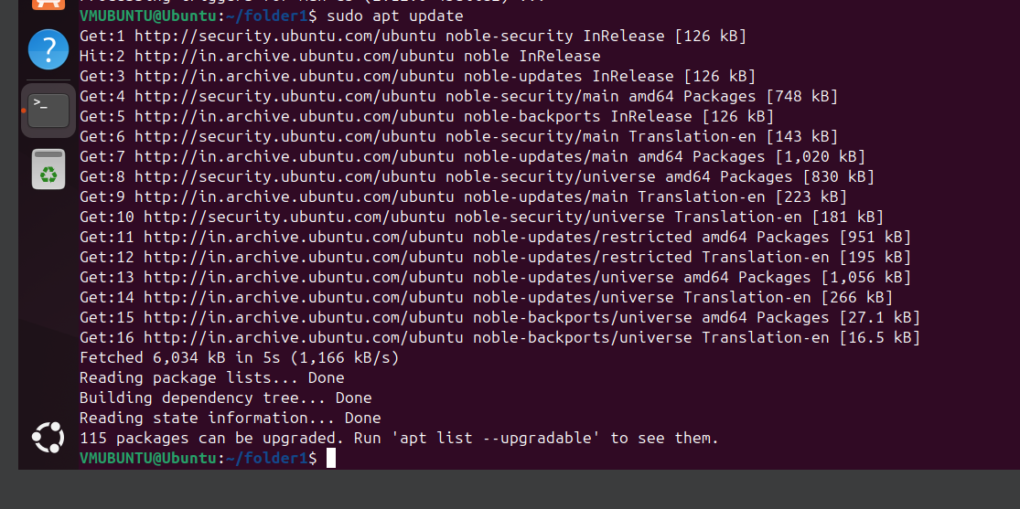

19) Create a symbolic link

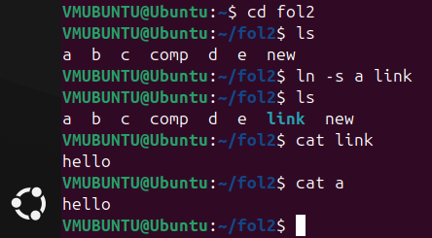

20) Search for files using the find command.

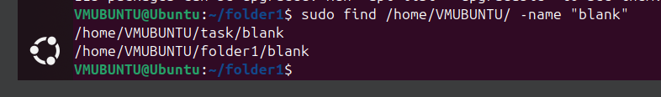

21) Compress and decompress files using tar.

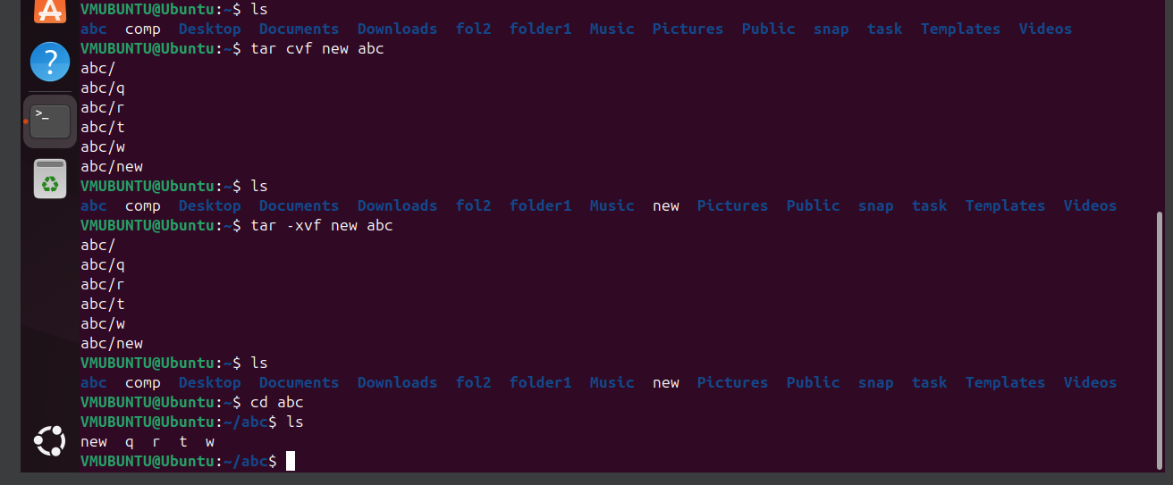

22) Monitor system resources with top or htop.

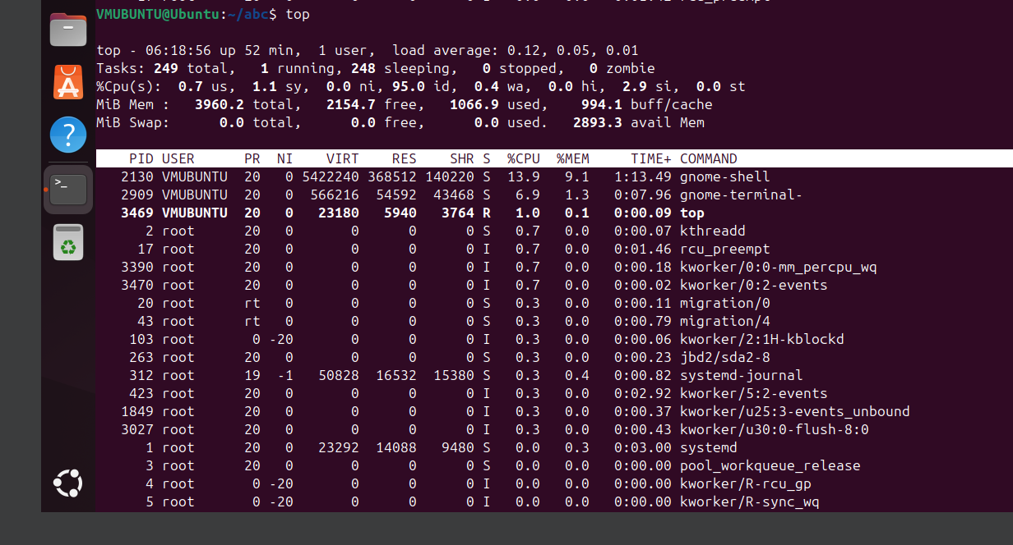

htop-

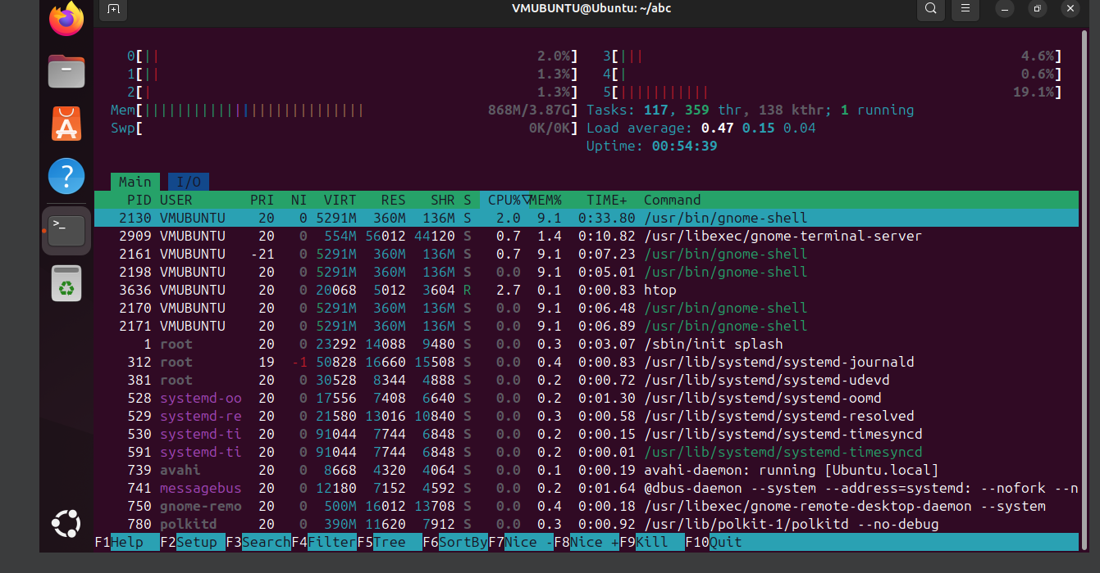

23) Create and manage user groups.

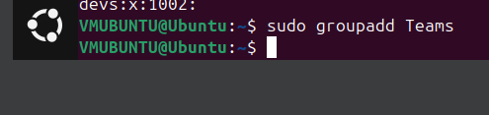



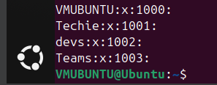

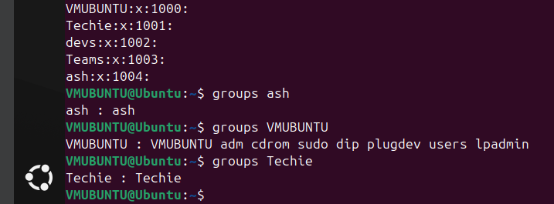

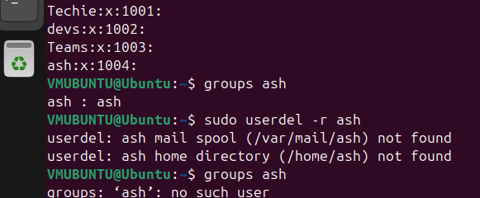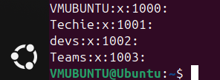

24) Set up SSH password less authentication.

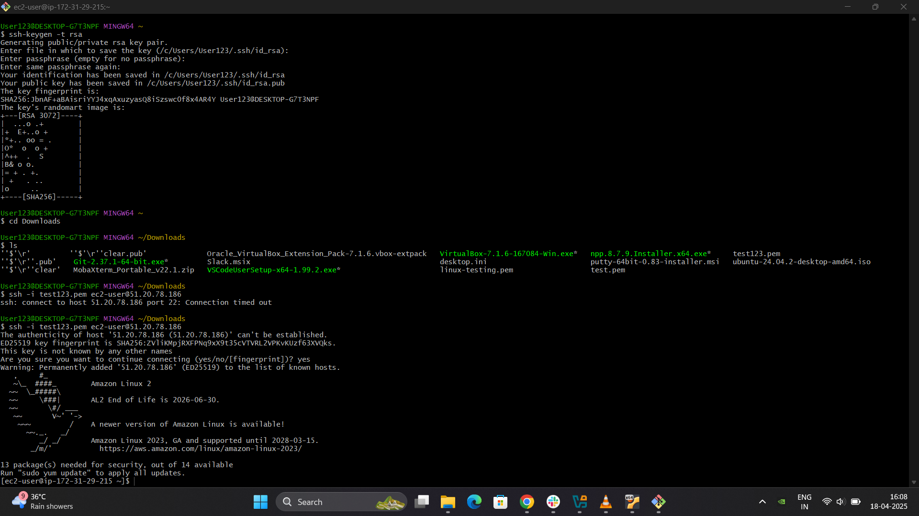

25) Monitor log files using tail or grep.

monitoring

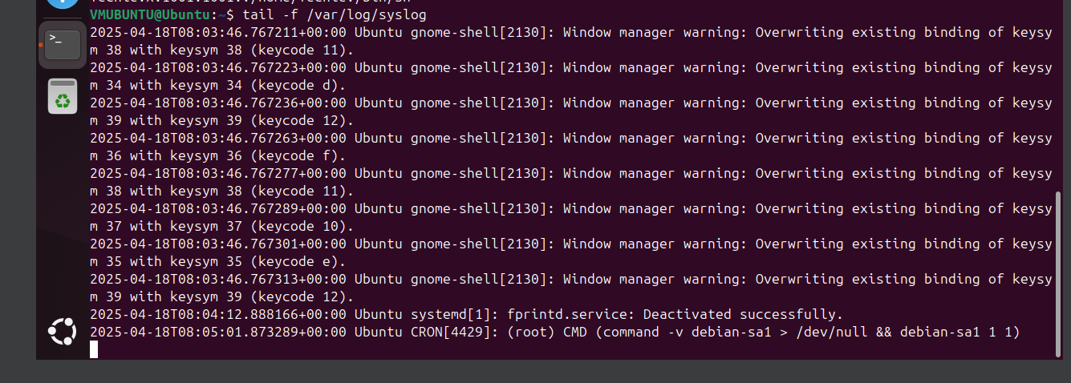

26) Set up a web server (e.g., Apache or Nginx).

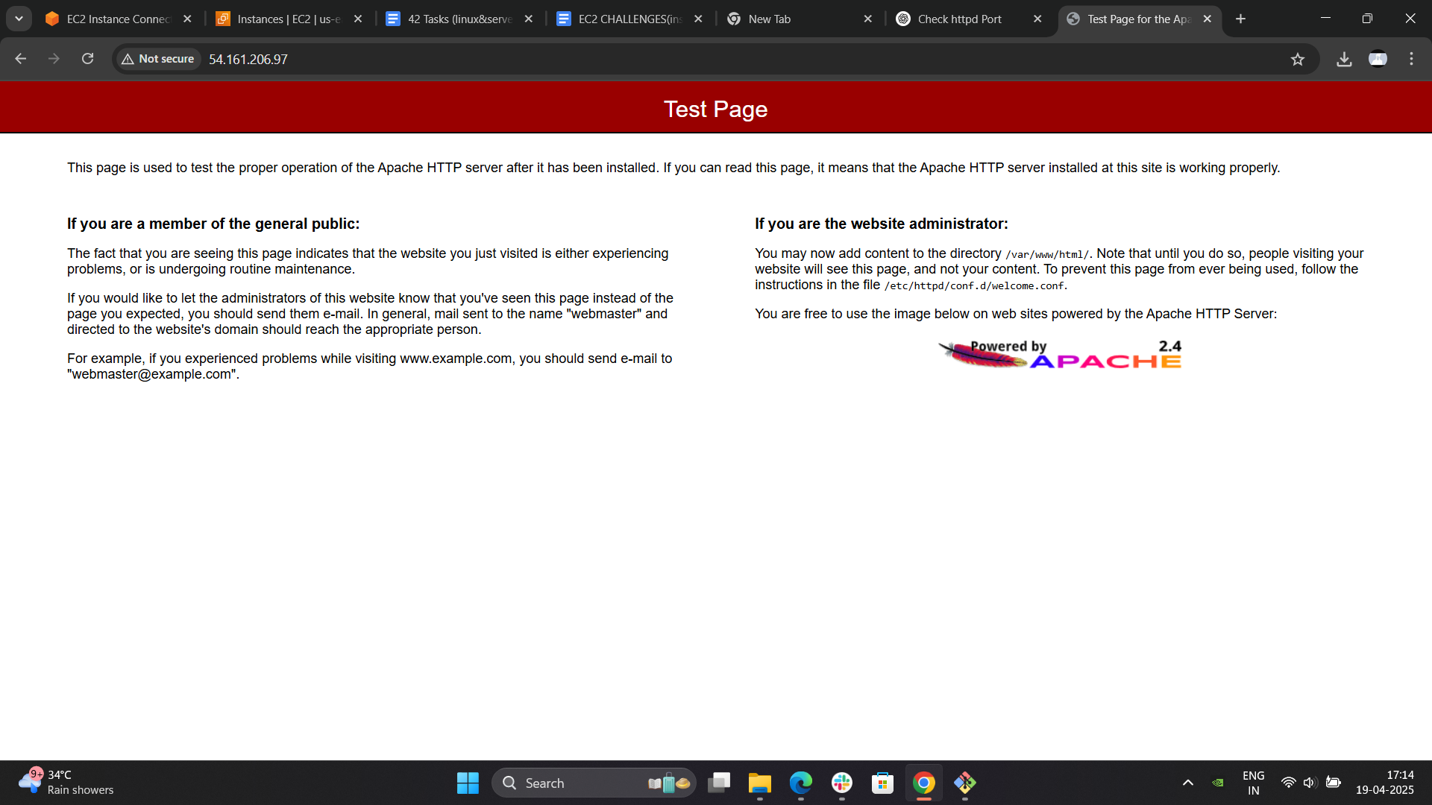

27) Configure and secure a MySQL Database.

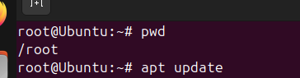

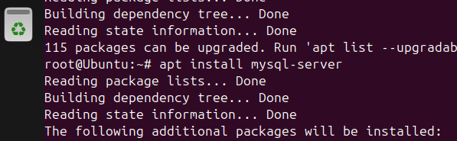

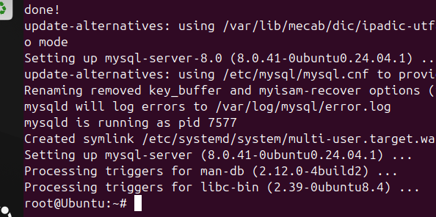

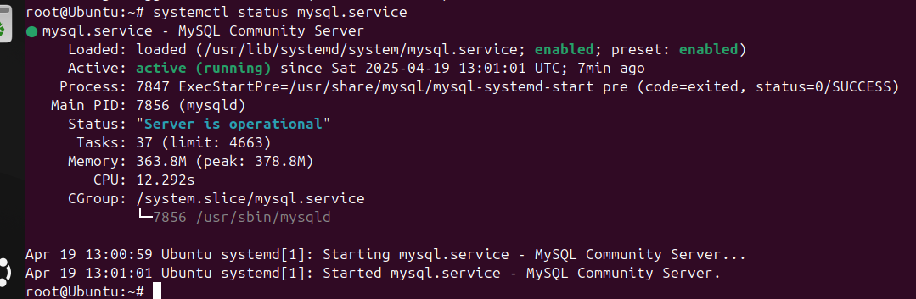

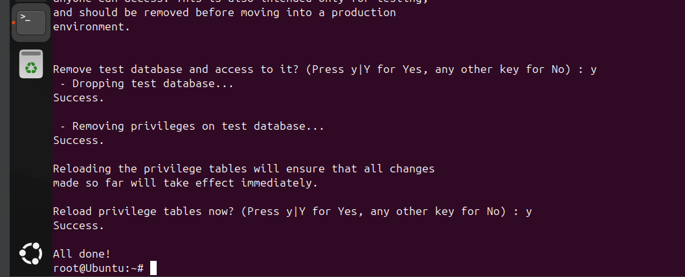

28) Set up a Application Server (e.g.,Apache Tomcat)

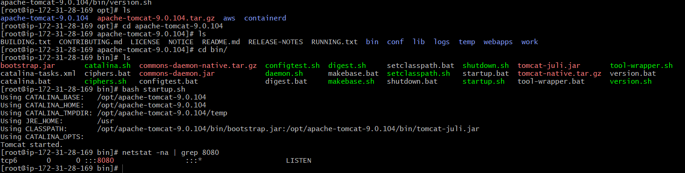

Changed the port no. by editing the server . xml file



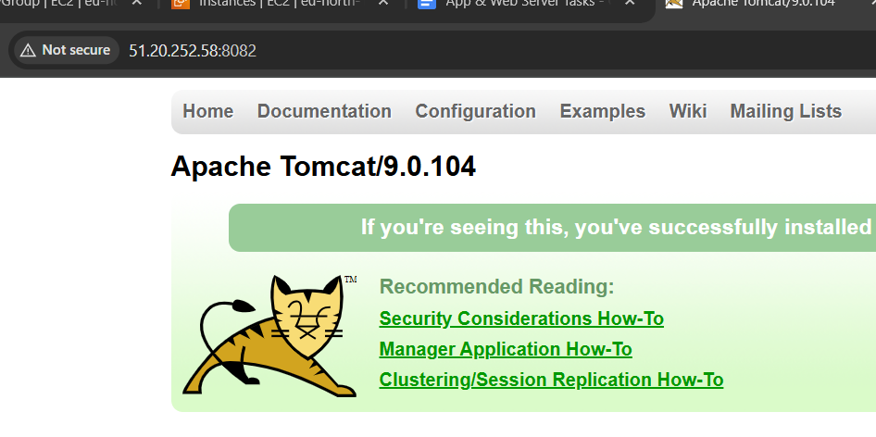

29) create a service file for Apache Tomcat.(Should execute by using systemtctl command)



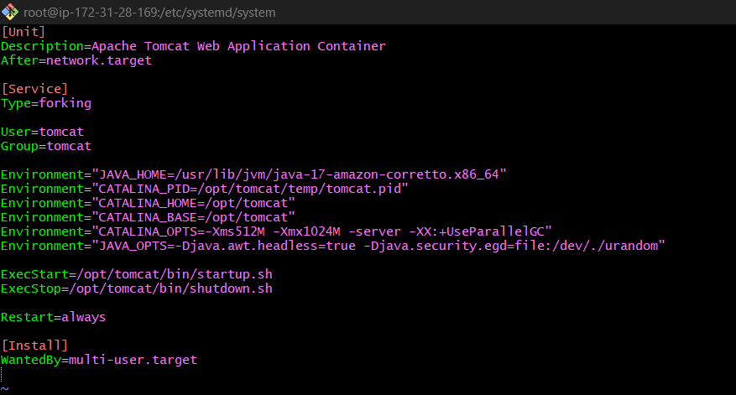

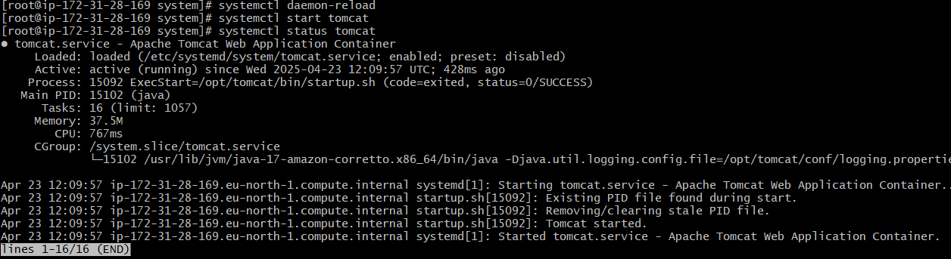

30) Print specific columns from a delimited file.

we read all the file content and printented only column 1,2,6

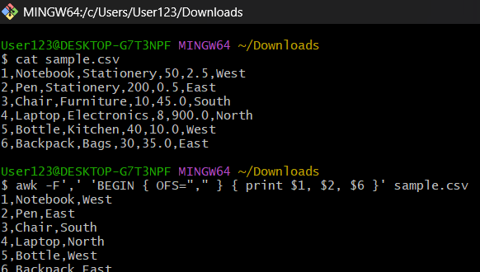

31) Filter and print lines based on a specific pattern or condition.

we are filtering lines the direction is west

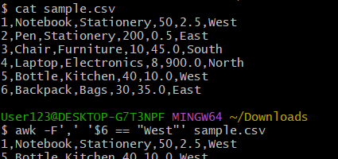

32) Calculate and print the average, sum, or other statistics of a column.

calculating the sum of column 5

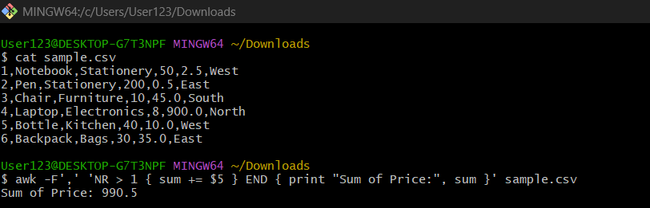

33) Perform string manipulation, such as extracting substrings or changing case.

Uppercase everything in second column

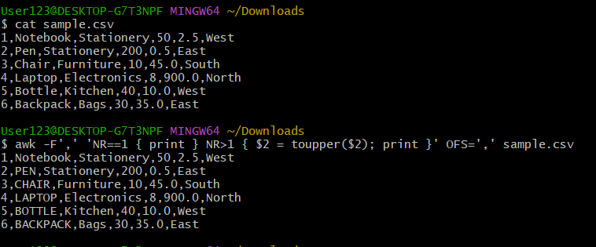

34) Count the occurrences of a specific pattern in a file.

counts the no. of times west is there

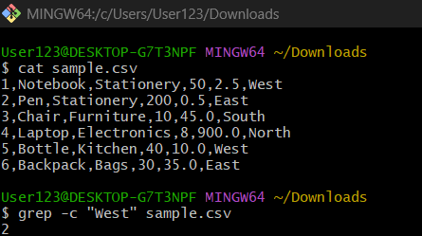

35) Sort lines based on a specific field or column.

sorting column 5 on price ,column 5

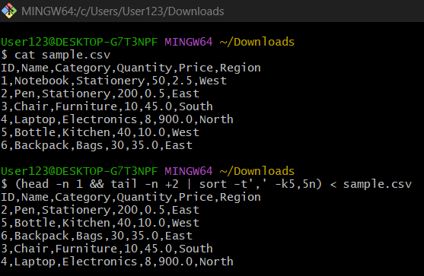

36) Merge multiple files based on a common field or column.

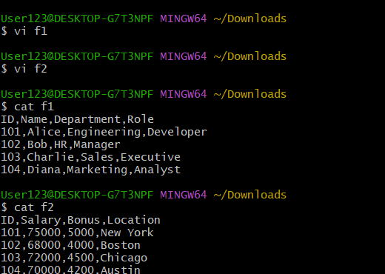

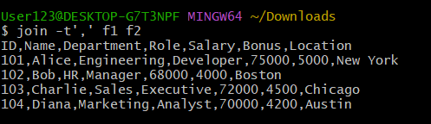

37) Substitute text in a file using search and replace.

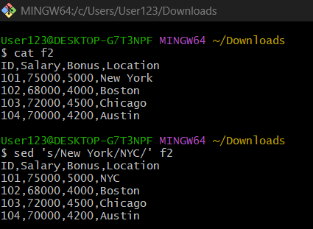

38) Delete specific lines based on a pattern or line number.  
  
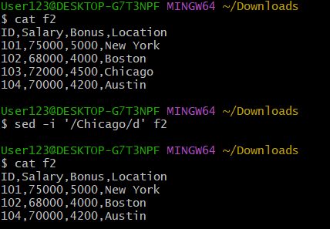

39) Append or insert text before or after a specific pattern or line.

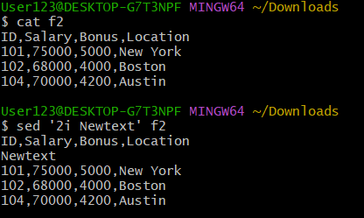

40) Print only specific lines from a file.

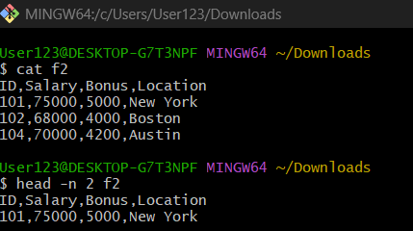

41) Copy file from linux to windows machine

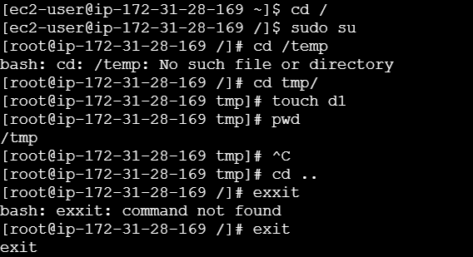



42) 5 use cases for AWK and 5 use cases for sed

print

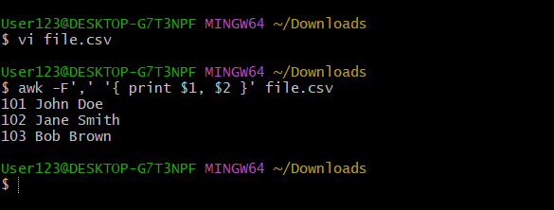

filter rows 70k

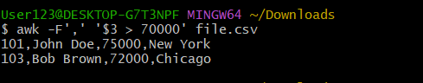

sum

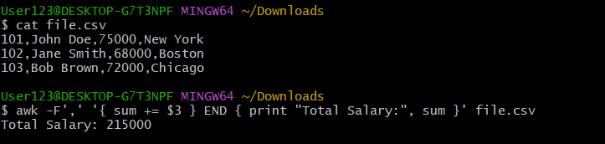

uppercase

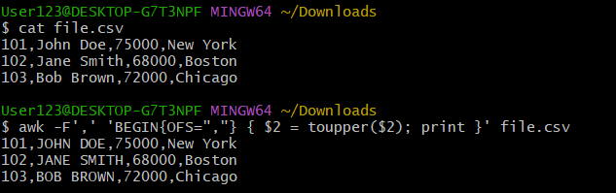

print cities

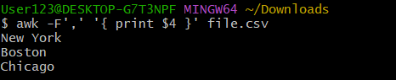

sed

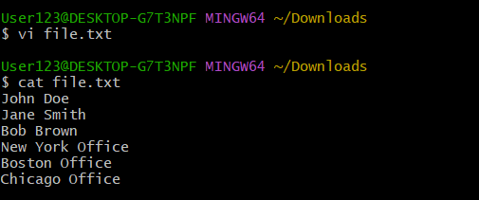

replace office with branch

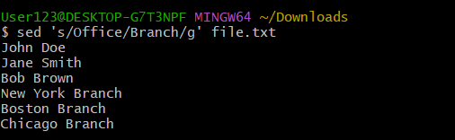

deleted smith

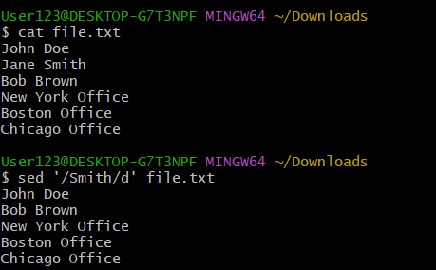

insert before line

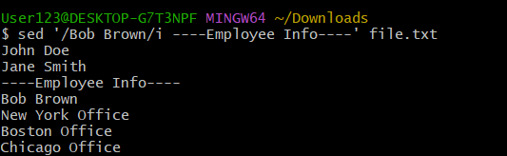

delete second file

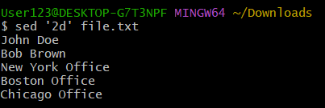

print only lines 4 to 6

